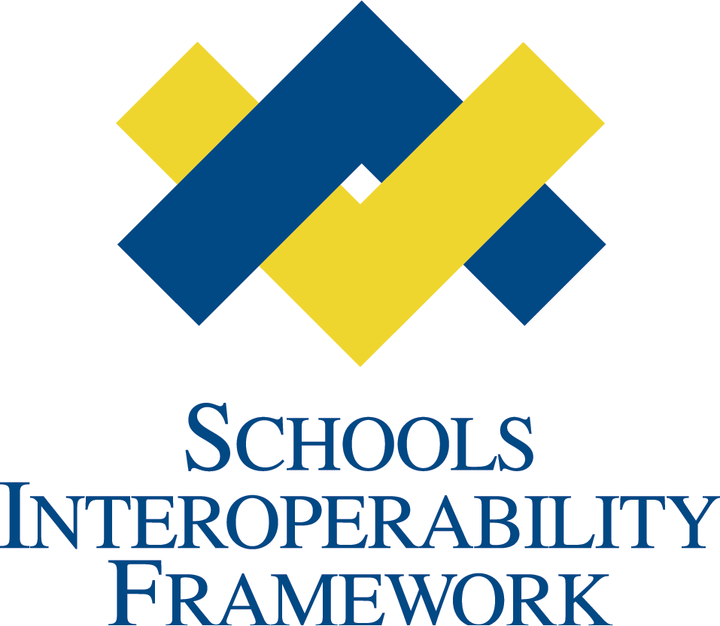

eTranscript Task Force

SIF v. 2.0 Object Plan
Business Case
V 0.10
VERSION CONTROL
Draft Specification Document Version Control
Version | Date: | Author/Organization: | Comments
0.1 |  | Barbara Andrepont/ESPSG;  Jill Hansen/AAL | First Draft
0.2 | 02/01/06 | Alex Jackl/ESPSG  Vince Paredes/ESPSG | Updated content – integrated context diagrams
0.7 | 02/04/06 | Barbara Andrepont/ ESPSG | Updated content
0.8 | 02/08/06 | Barbara Andrepont/ESPSG | Updated content, clarified mission, added to glossary
0.9 | 02/08/06 | Barbara Andrepont/ESPSG  Vince Paredes/ESPSG | Updated diagrams
.10 | 7/3/06 | Laurie Collins/SIFA | Updated Use Cases

SIFA Object(s) Business Case
Submission
Name of Submitter | Jill Hanson; Barbara Andrepont
Submitter’s Title | Co-Chairs, eTranscript Task Force
Submitter’s Organization | Administrative Assistants Ltd.; ESPSG
Date of Submission | 02/08/06
Form Submitted to: | SIF Staff __X____________  Tech Board __X____________  SIF Work Group ____X______

Object Plan:

Business Cases
Use Cases
Time Line
Detailed Object Dependencies
Detailed Object Changes
Detailed Infrastructure Changes
Object Description
XML Schema
XML Examples

eTranscript Task Force Mission

The mission of the eTranscript Task Force is to identify the SIF objects, elements, processes, security considerations, and the associated choreography needed to send electronic student records and transcripts between school districts and to postsecondary institutions.

It has become clear that the term “transcript” is widely assumed to denote student academic records being transferred to postsecondary institutions. The eTranscript work has adopted the term “student record exchange” to denote the sharing of PK-12 student records.

A student academic record is an official record of a student's academic work, including, but not limited to, a list of courses taken, grades received, credits awarded, and other information related to determining the student's status related to graduation or school completion. The Task Force focused initially on the essential information needed by the recipient organization to make an appropriate educational evaluation and placement of the student.

The eTranscript Task Force has leveraged the work of existing electronic transcript standards (e.g., Florida FASTER, Iowa EASIER, SPEEDE/ExPRESS, PESC XML Specification), to help ensure that SIF objects contain the relevant information.

Elementary and middle school academic records and other program participation information are also planned to be addressed in future work.

Every SIF Zone will be able to do this. SIF implementers can assume that student records (and transcripts) are available in this format.

Actors –
- Initiator – Student or Parent/Guardian requesting that the student record be transferred from the source institution to the target institution.
- Source – School, district, other clearinghouse institution providing the official student record.
- Target – School, district, clearing house, and/or postsecondary institution receiving the official student record.

Rationale

Although there are many variations the fundamental business case for the eTranscript Object Group is to provide data objects, transport objects, best practices, and choreography that supports:
- Sending electronic student records between school districts and,
- Sending electronic student records (transcripts) to postsecondary institutions.
- Multiple other use cases that will be described in Use Cases.

Secondary schools need to streamline the processing of transcripts in order to more efficiently use staff time and to provide new students with appropriate instructional services in a timely manner. Use of SIF objects and tools will enable the electronic exchange of student records between secondary schools and ensure that new students are swiftly placed into instructional programs that meet their academic needs.
Examples of roles that have been identified are:

Parent Role: The parent wishes to have a copy of the student’s current student records transferred to the school or district to which they are moving. The request is submitted to the high school guidance office secretary who forwards the request to the appropriate party at the school. The parent request authorizes that the student information be sent electronically to the school or district of their choice.

Secretary Role: The parent has requested the student’s current student records be sent to the district they are moving to so the district they are moving to will have the information in a timely manner. Currently there is no electronic way to send the information. Permission is obtain from the appropriate party at school that the student record may be released and the student is called down from class to obtain the paper copy to take home to the parent or the parent has to be called to come in and pick up the paper transcript. It would be better if there is a secure electronic way to transmit the student records to the appropriate learning institution.

Information Technology (IT) Role: The IT department has been requested to come up with a way for student’s records to be moved electronically. Currently the only method available to the school is for the appropriate part at the school to open a copy of the student’s record and save it as a text file that can be attached to an e-mail. This is an un-secure method and the IT department would like to use a data standard and XML language to transmit the requested information securely. The IT department feels that the requested could generate a trigger that would identify the requesting party as appropriate to request the information, the information would be compiled and the sent to the appropriate authenticated location.

How the Task Force Worked

The SIFA proposal incorporates work on prior electronic transcript standards (e.g., Florida FASTER, Iowa EASIER, SPEEDE/ExPRESS, PESC Postsecondary Transcript XML Specification) to further ensure that SIF objects contain the relevant information.

SIF eTranscript High-Level Architecture

This section describes the anticipated transmission methods conceptualized so far.

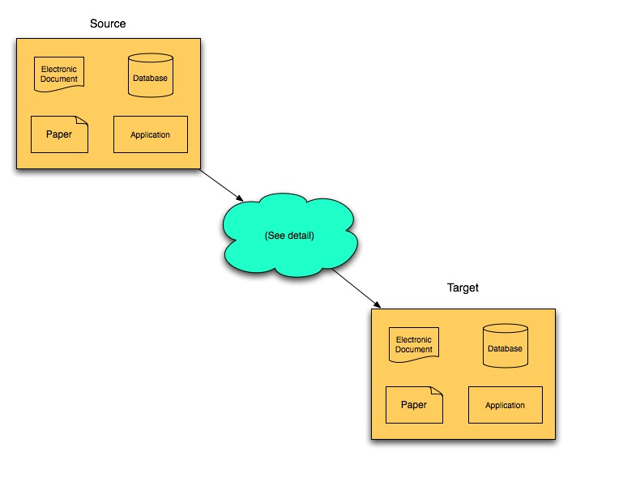

Figure 1 is a high-level picture of the student record exchange process. A student record in this context consists of any information a school district may keep about a student necessary to serve the educational needs of the student. The student record exchange document (eTranscript) is a subset of the information known to the source system. It is the information that target system needs to enroll and serve the new student.

The exchange document it transmitted from a source system to a target system. The source system may use any number of methods to store the information. The student record information may be contained, for example, as paper records, as an electronic document, in a database, or in a software application.
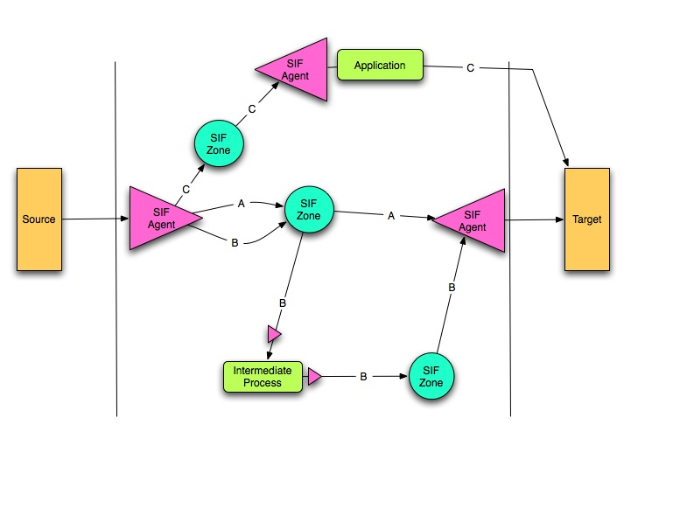

Figure 2 shows the paths an exchange document take when being transmitted via the standard SIF infrastructure.

Path A: An intermediary application registers in the same zone as the source system. The intermediary application delivers the document to the target system.

Path B: Both the source system and the target system agents are registered in the same SIF zone. A request-response transaction takes place in the SIF zone.

Path C: Both the source system and target system agents are registered in a SIF zone, but not the same SIF zone. An intermediate process delivers the document from one zone to another. One example of this type of intermediate process is SIF Vertical Reporting. Other intermediate process may be created.

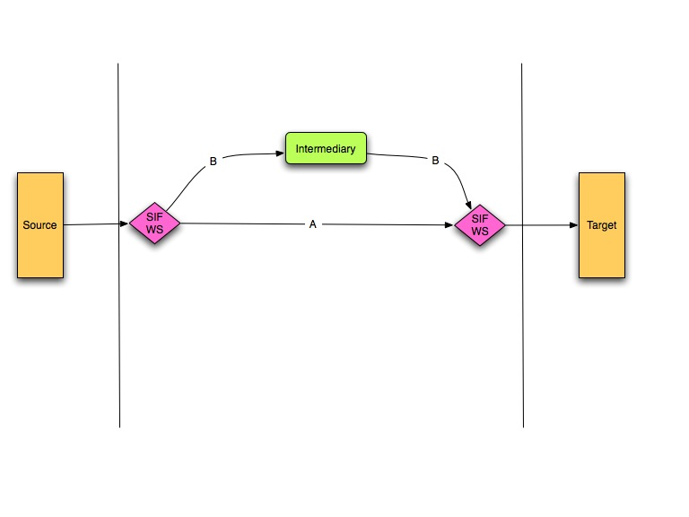
Figure 3 shows two options for moving a student record document via the new SIF web services specification.

Path A: The source and target systems communicate point-to-point using web services.

Path B: This path shows an intermediary system that relieves the source and target systems from managing registration with other systems.

eTranscript Use Cases

This section describes some initial use cases that have been developed. The use cases section of this proposal will present more detail.

1.1) High School to High School – A student record is sent when a high school student moves from one school (district) to another. Can also be used within a district when different schools use different SIS software. Course work is essential. Content areas include: Demographics, Course Info, Honors and Awards. Program Participation, Assessment, Health / Immunization Record, Standards Attainment, Discipline, Activities, and Portfolio.

2.1) High School to Postsecondary – A student record is sent when a student applies for admission to one or more postsecondary institutions (including vocational or other types of proprietary institutions). A student record is sent again when the student accepts. Content areas include: Demographics, Course Info, and Assessment, Activities, Honors and Awards, Portfolio.

2.1) “Pre-High” School to Another “Pre-High School” or High School –A student record is sent when an elementary or middle school student moves from one school/district to another. Would also be used within a district, when student moves between schools where different SIS software is in use. Content areas include: Demographics, Course Info, Program Participation, Assessment, Health / Immunization Record, Standards Attainment, Discipline, Guardianship, Portfolio.

4.1) School/District (“Pre-High School” or High School) to Migrant Education Program – A student record is sent to a state migrant education program. Content areas include: Demographics, Course Info, Program Participation, and other relevant specified information.

5.1) Virtual School to School/District – A record is sent when a student is enrolled in or completes a course in a virtual school to the school or district of record for the student. Content areas include: Demographics, Course Info and perhaps Standards Attainment.

6.1) Postsecondary Institution to High School – A student record is sent to the high school of record when a student completes a course at the postsecondary level while he or she is still attending high school. Content areas include: Demographics, Course Info, Portfolio.

7.1) School/District to State – A record is sent for each student taking high school courses or other information required by the SEA.

8.1) Public School/District to Private School – A record is sent to a private school when a student enrolls. This can also go from private to public. Content areas include: Demographics, Course Info, Program Participation, Assessment, Activities, Portfolio.

9.1) High School to NCAA Clearinghouse – A record is sent to the NCAA Clearinghouse for a student who is seeking to participate in athletics at the postsecondary level. Content areas include: Demographics, Course Info, Activities, Honors and Awards.

10.1) High School to Employer – A student record is sent to a potential employer for a high school student or graduate. Content areas include: Demographics, Course Info, Activities, Honors and Awards, Portfolio.

11.1) High School to Postsecondary Lending Organizations – A student record is sent to lending organizations that provide grants and loans to high school graduates. Content areas include: Demographics, Course Info, Honors and Awards.

12.1) High School to Scholarship Organizations – A student record is sent to organizations from whom scholarships are being sought. Content areas include: Demographics, Course Info, Program Participation, Activities, Honors and Awards.

GLOSSARY

Transcript | An official record of a student's academic work, including, but not limited to, a list of courses taken, grades received, and credits awarded. The education community commonly uses the term to refer to high school to postsecondary academic history documents.
Choreography | Defined sequences of message exchanges.
Course | The organization of subject matter and related learning experiences provided for the instruction of students on a regular or systematic basis, usually for a predetermined period of time (e.g., a semester or two-week workshop) to an individual or group of students (e.g., a class). (NCES Handbooks Online, 2006)
Grade Earned | A final indicator of student performance in a class as submitted by the instructor. (NCES Handbooks Online, 2006)
Assessment | A tool, instrument, process, or exhibition composed of a systematic sampling of behavior for measuring a student's competence, knowledge, skills or behavior. An assessment can be used to measure differences in individuals or groups and changes in performance from one occasion to the next. (NCES Handbooks Online, 2006)
Assessment Results | The group of assessment data elements used to communicate the status of student’s performance on an assessment. Assessment data elements would include the assessment title, administration date (or timeframe), and assessment rubric/rating.
Assessment Rubric/Rating | An indication of the quantitative or qualitative range of possible scores/rating for an individual's performance on an assessment. (NCES Handbooks Online, 2006)
Articulation | Articulation agreements are formal agreements between two (postsecondary) campuses. The agreement defines how courses taken at one (college or university) campus may be used to satisfy a subject matter requirement at another (college or university) campus.
Graduation Requirements | Courses and other requirements that the student must meet in order to graduate.
Student record | Records of student information, including student demographic information, program participation, assessment results, e.g. program participation (special education, Title I, limited English proficiency), immunizations, etc.
Portfolio | Artifacts of student work (i.e. works of art, written compositions, video recording of performance, etc.). Artifacts could be represented as pdf files, WORD documents, jpeg files, .wav files, etc. (Alex Jackl)
Program | A program is a set (plan) of activities and procedures designed to accomplish a predetermined objective or set of objectives. (NCES Handbooks Online, 2006)
Program Participation | Identification of the student’s involvement in programs in the most recent school year.
Source | School, district or other organization expected to send the student record data in the exchange.
Target | School, district or other organization expecting to receive the student record data in the exchange.
Exchange Document | The exchange document consists of the objects (data elements) comprising the student record to be sent from the Source to the Target.
Student Record Request | Student Record requests are the objects (data elements) comprising the request for a specific student record. The student record request is sent from the Target to the Source.
Health Records | Health records are the objects (data elements) describing a student’s health conditions, diseases, illnesses, assessments, treatment, plans, care requirements, care procedures, and progress.
Immunization Records | Students are required to provide records of vaccinations for childhood diseases (or doctor’s exemptions from the immunizations) for school entrance. Record contents would include vaccine type, administration date of each dose and booster, and any exemptions with date and reason.
Discipline Records | Records of student involvement in disciplinary incidents and actions include identification of the type or category of the infraction (discipline incident), the discipline imposed (e.g. suspension, placement in an alternative program, or expulsion), and the duration of the discipline.
Course History | The course history includes student records of courses taken, grades awarded, credits attempted, credits earned, associated to the school where the course work was done.
In-Process Course | In-process course records are the student’s records on courses underway or left incomplete when the student record is prepared, including course information, interim grades (not the final grade), credits attempted, associated to the school where the course work was being done. (Guidance counselors referred to these records as a “drop slip,” where teachers provided information as the student dropped courses departing for the next school.)
Student Demographic Records | Information about the student, including name, student identifier numbers, race, gender, date of birth, parent and student contact information, and flags on student program participation.
Standards Attainment Records | Standards attainment records indicate the student’s mastery of specific state or local instructional standards. Standards attainment records are more visible in elementary grades.
Honors/Awards/ Activities Records | Records of student honors, awards and participation in school activities (sports, clubs) further characterize the student’s engagement in the school community. These records could also include scholarship eligibility or award.
Official Record | Student records which are certified by an education agency to be accurate.
Degree Granted | Official documentation of the education program that has been successfully completed.
Agency Seal or Official Signature | Physical or electronic symbol, icon or name affixed to a document to indicate its authenticity.

